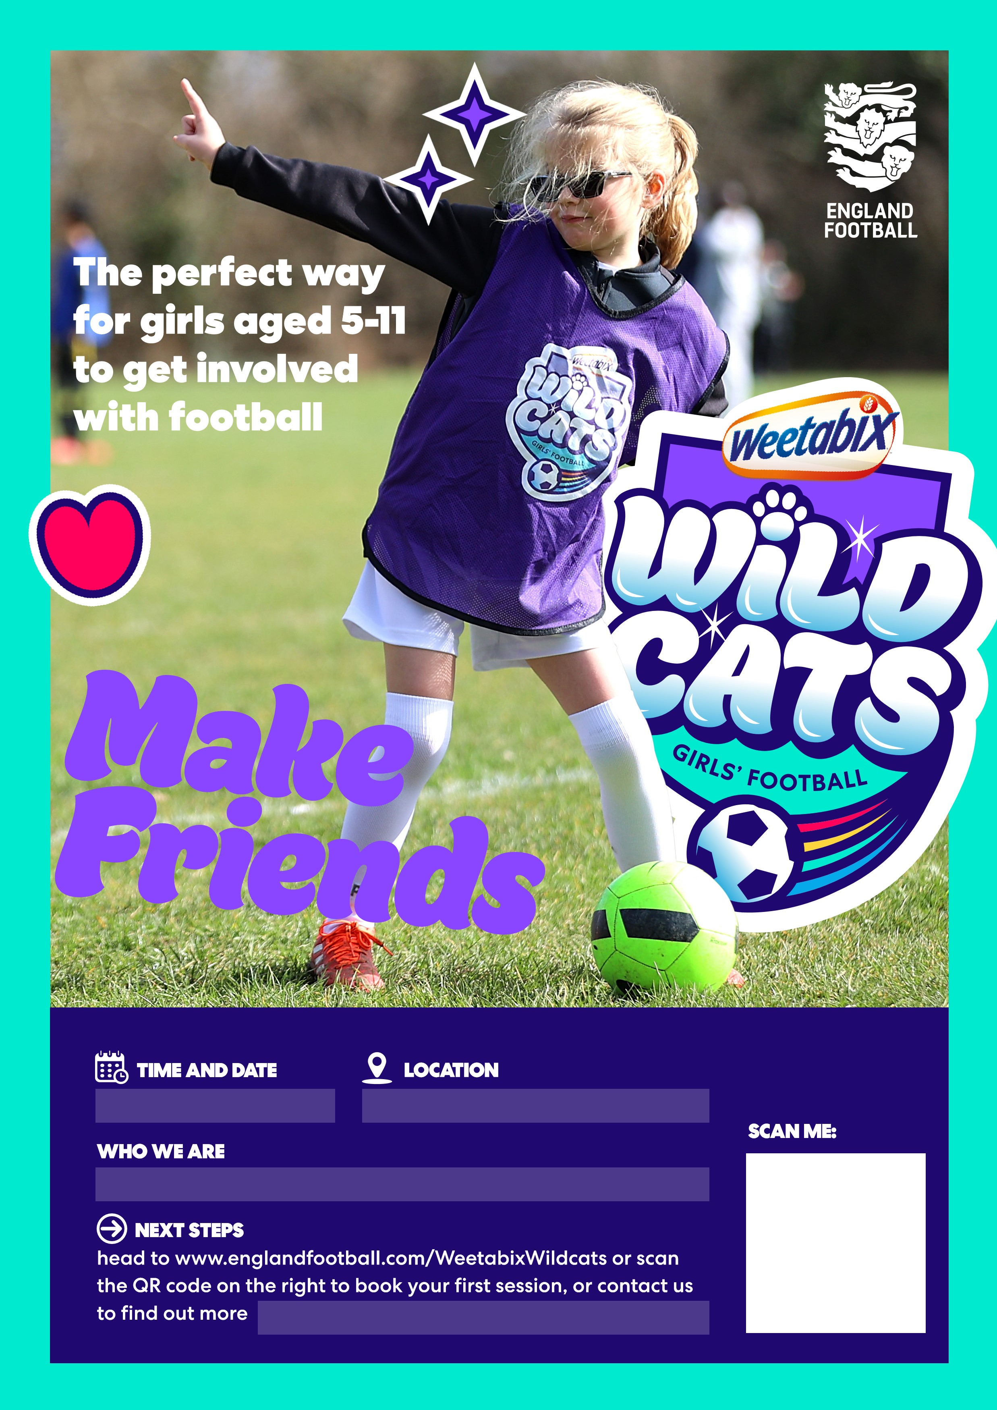

**cleung@rotherhamunited.net**

**Rotherham United Community Trust**

**Parkgate Astro, S62 6FH**

**Every Thursday, 4-5pm**